## Sky Gazing Members

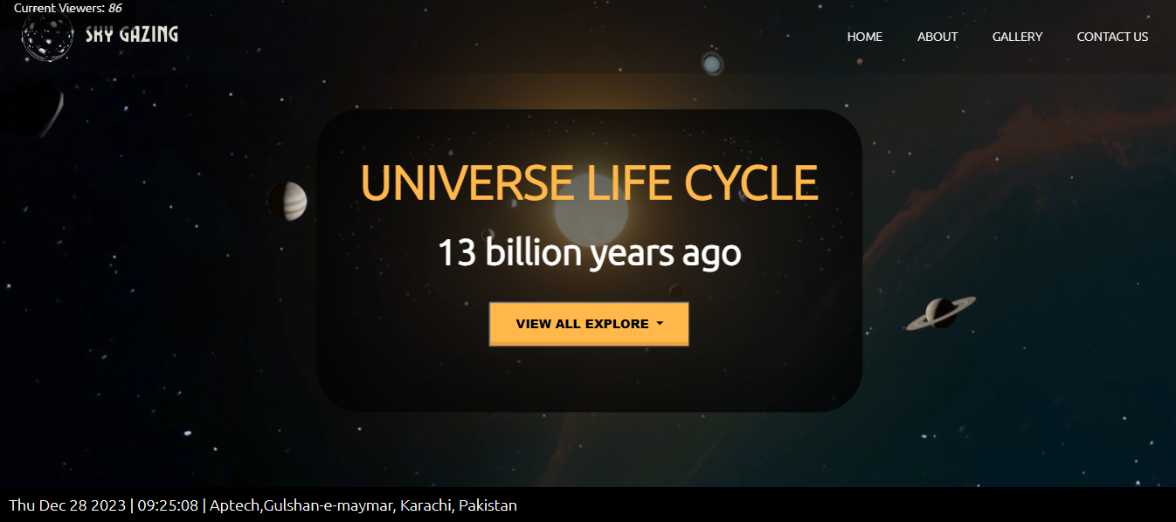

BATCH CODE: PR-202307D

## Our Group Members:

## Muhammad Abdullah Siddiqui :

## (Student1489050)

## Syed Muhammad Taha:

## (Student1486391)

## Muhammad Hussain Khan:

**Submitted To:**

[eprojects@aptech.ac.in](mailto:eprojects@aptech.ac.in)

**Project Instructor:**

**Sir Muhammad Hashir Siddiqui**

## (Student1488941)

## Curriculum Code:

## Muhammad Abdullah Siddiqui :

## (OV-7062-ADSE)

## Syed Muhammad Taha:

## (OV-7066-HDSE)

## Muhammad Hussain Khan:

## (OV-7062-HDSE)